System Specification

The Generator Datasheet
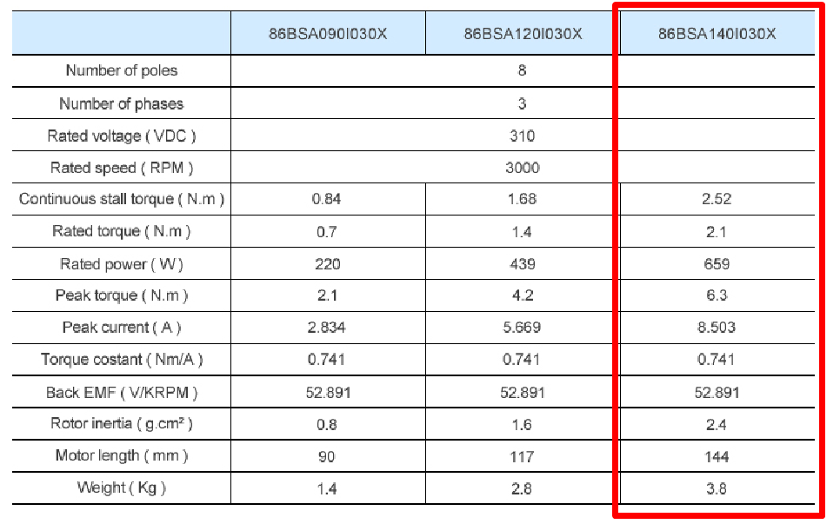
Note: This datasheet needs to be checked because some measurements are not consistent. Ignoring the Back-Emf constant of the datasheet and considering the torque constant, the back-emf constant should be around 77.6 V / kRPM.

The Rectifier Circuit Specification
- Maximum Line-to-Line input Voltage ($V_{max}$)
$$V_{max}=BackEMF (V/kRPM)×MaximumRotationSpeed (kRPM)$$
$$=77.6×4.5$$
$$=350V$$

- Rated Output Current ($I_{o}$)
$$I_{o}=RatedTorque\left(Nm\right)/TorqueConstant\left(Nm/A\right)$$
$$=2.1/0.741$$
$$=2.8A$$

